Unit testing

1. Create new Win32 project as DLL library.

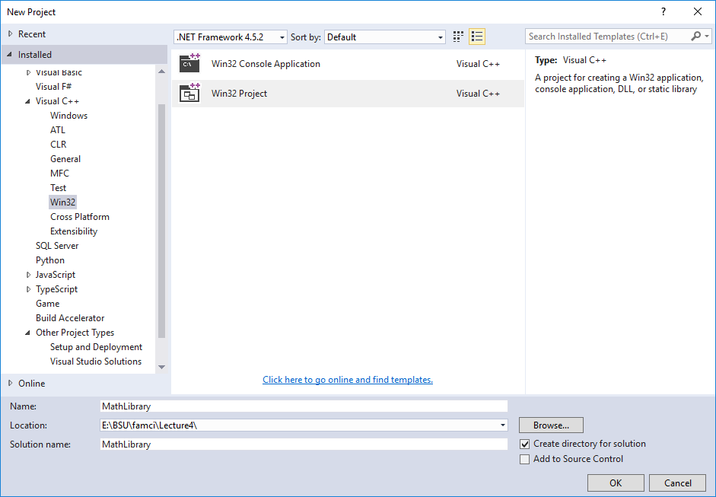

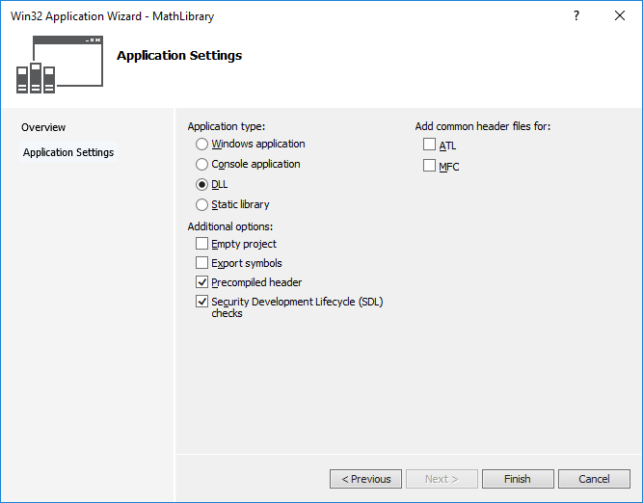

1. Add header file MathLibrary.h and MathLibrary.cpp

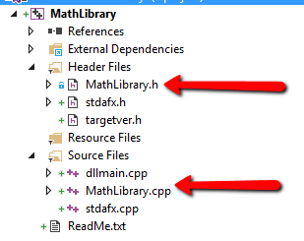

1. Create Console Application project that uses our MathLibrary.

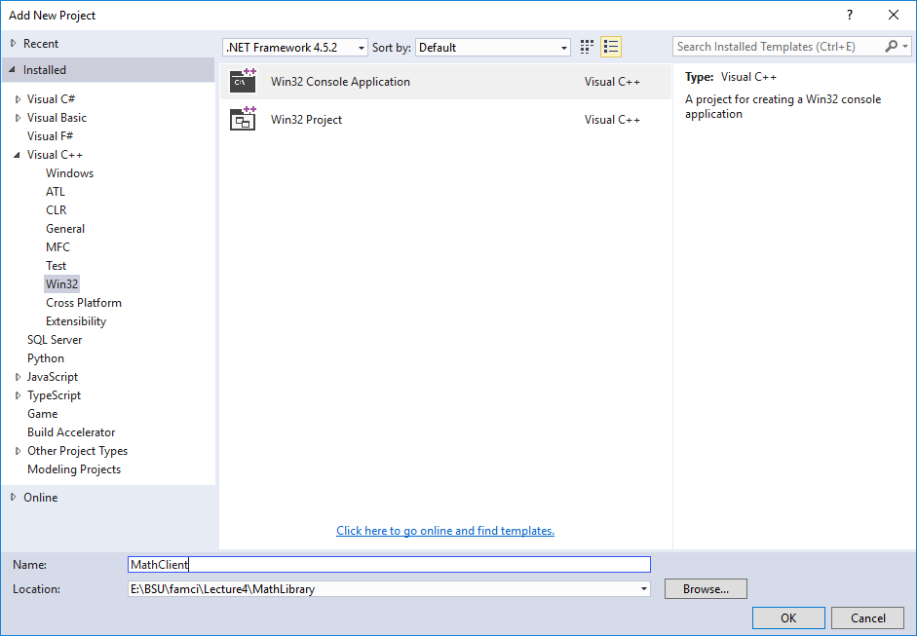

1. Add reference to MathLibrary DLL into ConsoleApplication project.(OR simply copy it, but in this case you need to update MathLibrary.h each time when you change it in DLL project).

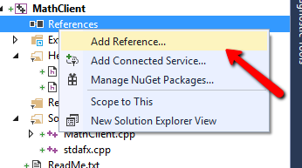

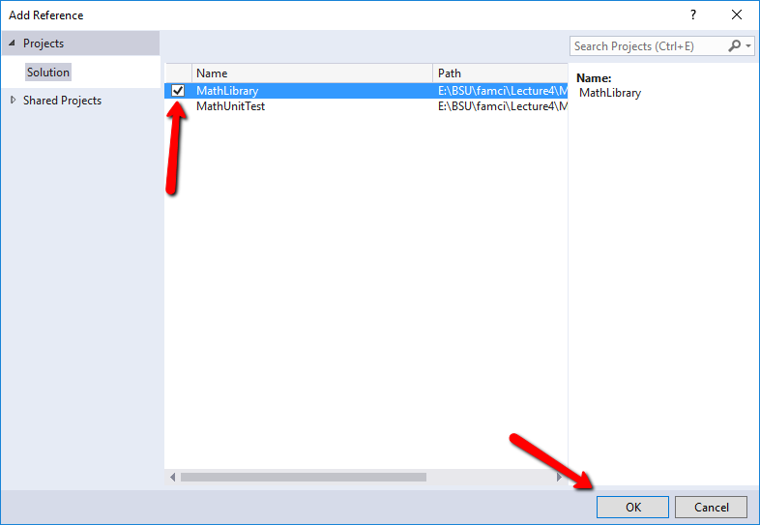

1. In MathClient.cpp use the relative path to MathLibrary.h file:

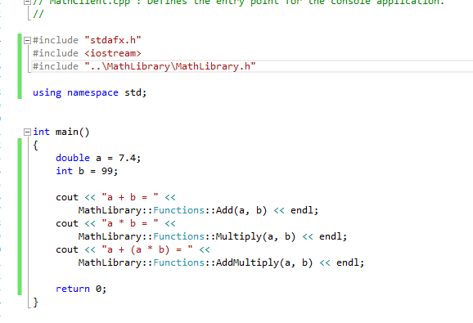

1. Create Unit Test project

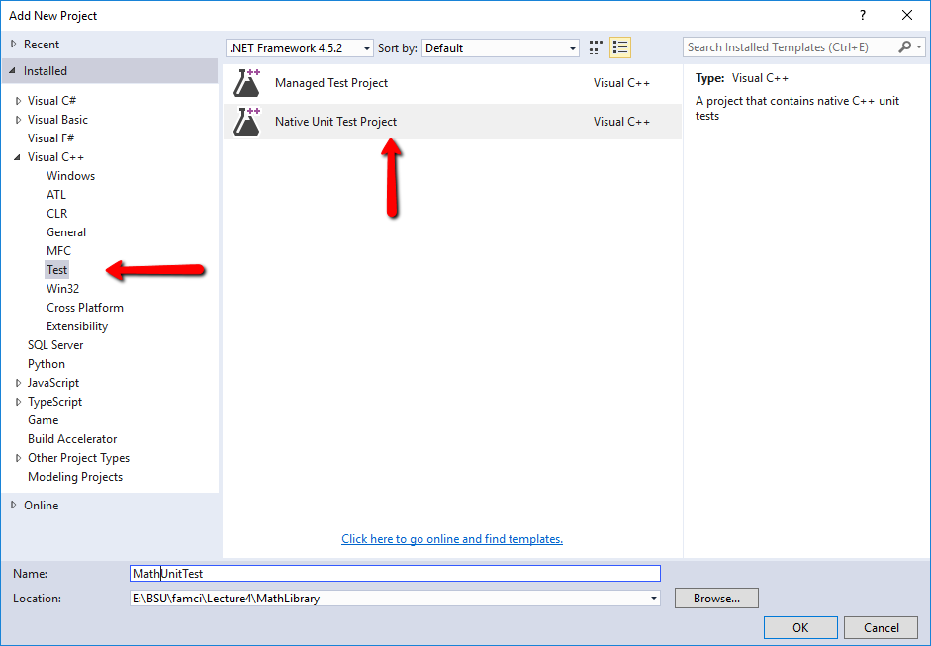

1. To show Test Explorer window, open it via top level menu Test ->Windows ->Test Explorer.

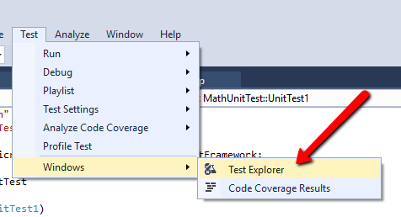

1. To check that test works, add the following line of code and run test in Test Explorer:

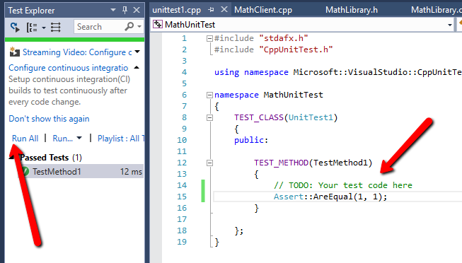

1. Add reference to the MathLibrary DLL as it was already done for MathCLient. Include MathLibrary.h using relative path and implement the test for method Add:

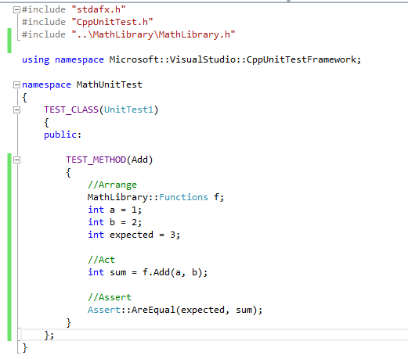

MathLibrary.h

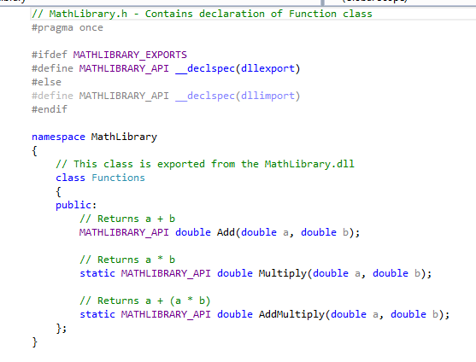

MathLibrary.cpp

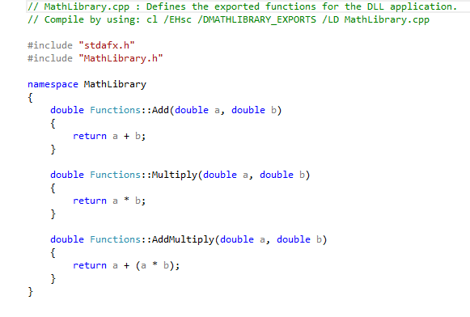

MathClient.cpp

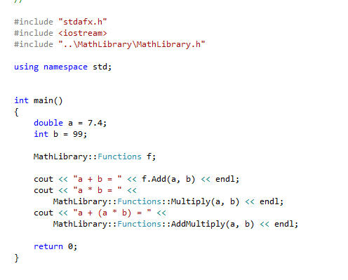

Unittest1.cpp

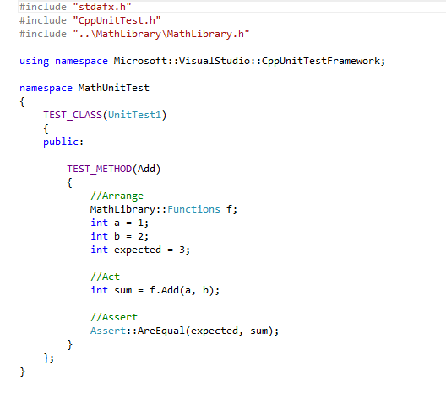

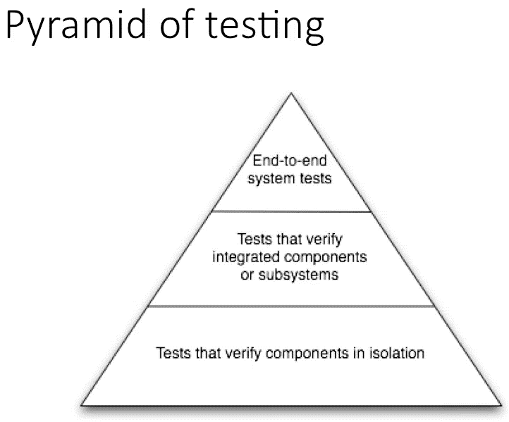

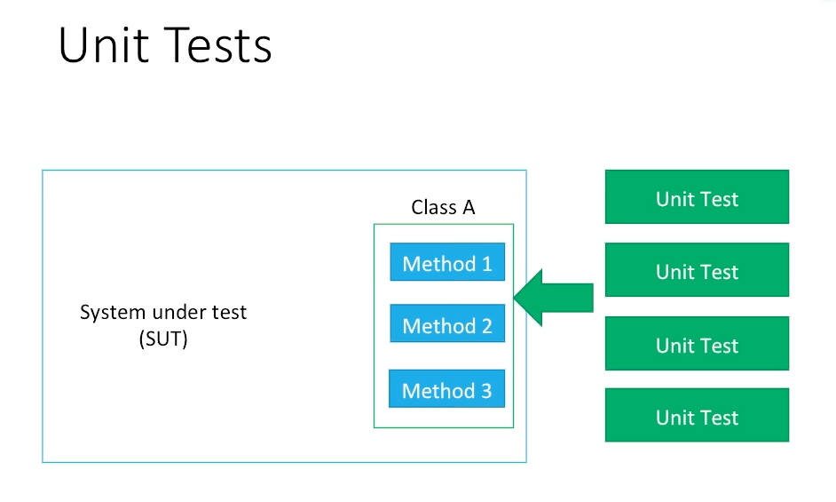

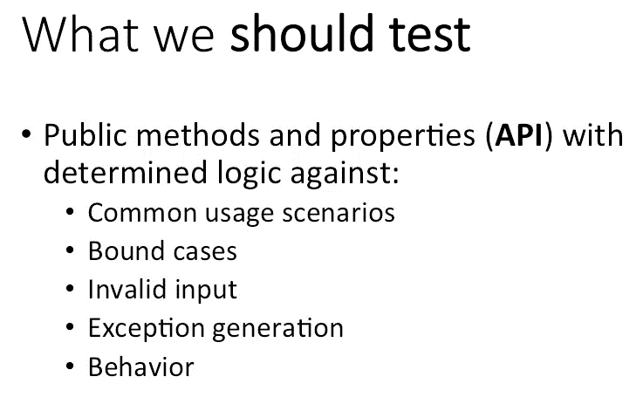

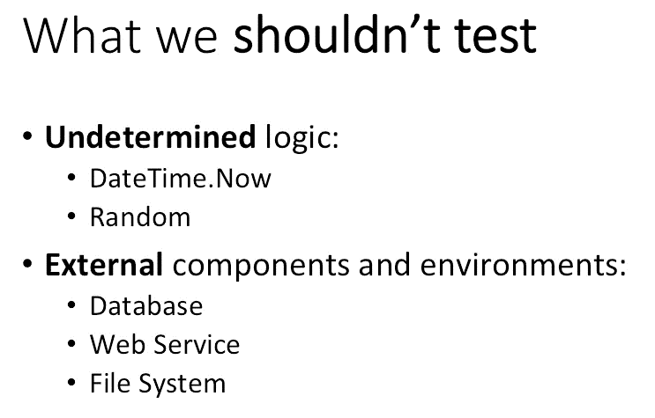

**Benefits**:

* Reduction of bugs
* Fear of changes(we don’t afraid that broke smth) - Regression
* Don’t spend time on debugging (web site build may take too much time)
* Improve code design
* Improve developers level

**Issues**:

* Extra time and efforts
* Initially negative attitude
* Doesn’t test integration
* Possible trust issue(it’s difficult to cover the whole functionality, or you can write green test that doesn’t test feature at all)

